**A SOPHISTICATED PRIORITY-BASED TRAFFIC MANAGEMENT SYSTEM FOR EMERGENCY VEHICLES**

**BREIF ABOUT THE PROBLEM STATEMENT**

Traffic congestion delays are to responsible for 20% of emergency patient deaths each year. More than 50% of heart attack patients arrive at the hospital too late. The main issue is that no one reacts until the ambulance gets there, making it difficult for the ambulance to go where it has to go. In order to reduce these death rates.

In today's society, traffic, as the primary worry, is causing several challenges in everyday life. Apart from the usual difficulties of congestion, it seriously impedes the proper operation of emergency vehicles. Emergency cars must be prioritised over all other vehicles, however due to unforeseen circumstances or self-centred motorists, emergency vehicles do not arrive at their destinations on time. The delayed arrival of emergency vehicles may endanger lives.

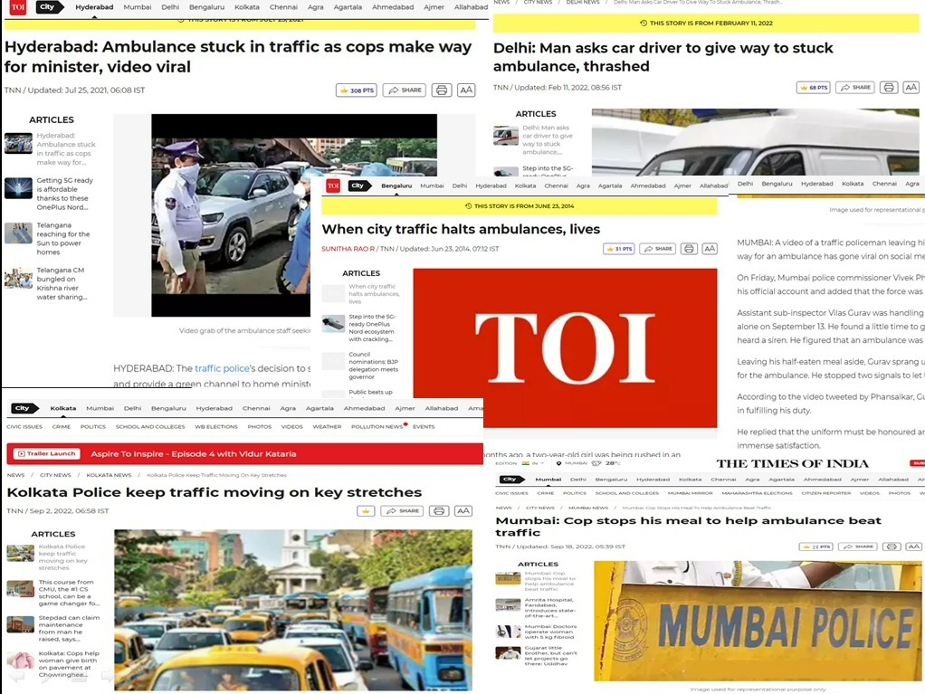

**Uniqueness in our System**

* An AI-based Ambulance Service System in Congested Areas.
* IoT-based System for Siren Deduction.
* System for EMS Services Based on WEB Application in Congested Areas.

To develop a hybrid system, these solutions are merged.

**Introduction**

It is crucial to offer emergency care in the crucial first few minutes following an accident in order to save human lives. To stop fatalities and hasten the recovery, emergency medical treatments must be delivered quickly. This is especially true for respiratory problems, heart failure, trauma, and drowning. Despite the high volume of traffic, services and lifesaving medical equipment may be transported.

Apparently, there must be a mechanism that identifies the emergency vehicle before it arrives at the intersection and clears the traffic ahead of it. This may save delays and help those in need during an emergency. As the principal source of concern in today's society, traffic presents a number of difficulties in daily living. It significantly impedes the correct functioning of emergency vehicles, aside from the ordinary issues of congestion. Emergency vehicles must take precedence over all other vehicles; nevertheless, owing to unforeseen events or self-centred drivers, emergency vehicles do not arrive on time. The delayed arrival of emergency vehicles.

There must be a device in place that recognises the emergency vehicle before it reaches at the junction and clears the traffic ahead of it. This might save time and assist individuals in need in an emergency. The fundamental goal of an intelligent traffic control system is to minimise delays brought on by traffic congestion by ensuring a smooth flow so that ambulances may get at hospitals on time. One of the major issues in Indian cities nowadays is the traffic. Although the number of vehicles on city roadways is rising daily, the city's roads and infrastructure are not progressing as anticipated. The management of traffic lights is crucial in preventing traffic jams. The effort put out by police officers performing their responsibilities in response to signals is reduced by this regulating system. The system is intended to track the amount of traffic on the route.

Automation involves replacing human labour with mechanical or material components. These parts or robots employ artificial intelligence to function similarly to humans. Ambulances cannot make it to the destination quickly due to the dense traffic in metropolitan areas. The majority of nations deploy police escorts to make room for ambulances. Use of technology is preferable than exerting human effort or energy. We employ artificially intelligent Systems as a sort of technology. open up several robotics applications. Signalling the cars is accomplished through verbal orders and signals. Traffic delays can reduce the number of fatalities. Police escorts can be replaced by Systems. AI for System control and obstacle avoidance increases efficiency. The use of AI technology lessens the need for human labour.

Every lane of a given crossroads has one or more smart object(s) installed. These object(s) are made to detect the incoming emergency vehicle's siren, which activates a camera to take pictures. The camera then uses the photos to determine whether the vehicle is an emergency vehicle or not. The signal is sent to the Decision Support System if the car is recognised as an emergency vehicle. By detecting the lane that the emergency vehicle is entering, the Decision Support System can move traffic. The other signal lights at the intersection are all red.

**OBJECTIVE:**

Our work's major goal is to employ technology rather than labour rather than human effort. The death rate brought on by ambulance delays may be reduced. minimising the amount of time spent travelling by giving the ambulance a clean path. not just at the lights, but also the whole route used by the ambulance. Accurate and effective data collection will enable the provision of the service. Use of this technology is possible to prevent collisions and impediments.

Technology involved in the use case :-

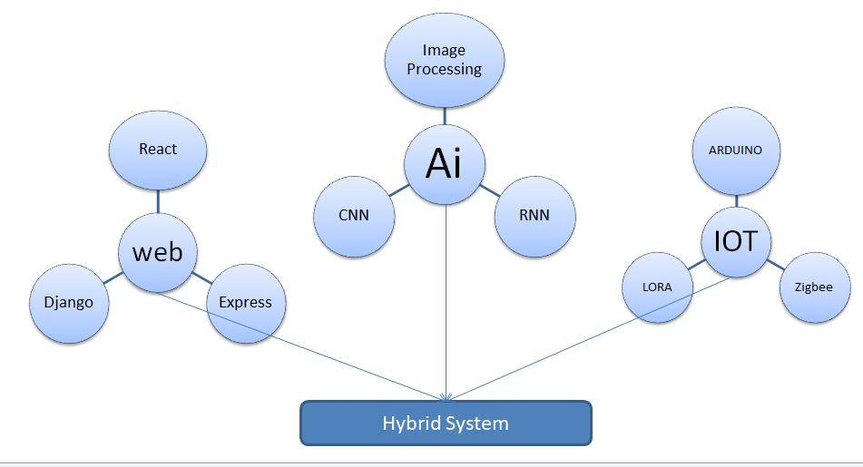

**WORKING:**

**API**

For the ambulance, an application will be made. The ambulance driver can record the emergency case using that programme. The visual processing will then detect where the ambulance is coming from when it gets closer to the signal. It will block the signals from functioning normally and turn off all of them except for the one that the ambulance needs to pass through. Your application will be connected to the traffic signal control system so that the entries may be saved in the database. Connect the traffic signals and the image processing as well. We also need to develop signal-manipulation skills..

We have divided the development of this project into the components listed below.

**Module 1: Admin**

**Module 2: Automobile/Medical**

**Module 3: Signal Control**

**Module 1: Administration**

The route information for the ambulance drivers is entirely the responsibility of this module. Additionally, it will keep tabs on and track the ambulance's arrival and departure points.

**Module 2: Automobile/Medical**

This module is in charge of asking the administrator for authorization to enter the location. The driver must wait for the route after sending his request. Following the selection of the route, the driver will request the creation of a green corridor from a cloud database.

**Module 3: Signal control**

The modification of the signals is the focus of this module. The cameras will start to take pictures as soon as the cloud receives the request. As soon as the ambulance is seen, it will confirm and offer a green corridor.

The project's flow is shown in the accompanying figure. The official hospital representative known as the admin will notify the driver when an organ is ready to be sent for transplant. The notice will be given to the driver, who will then choose the source and destination paths. After learning the position of the ambulance, the administrator will notify the traffic control division to open a green corridor for it. The ambulance's driver will be able to follow it so they can be sure it will arrive at the right place.

**GPS Unit:**

The term Global System for Mobile Communication, or GPS Module, is an acronym. The digitalized cellular technology is utilised to transmit mobile and voice data services.GPS is a device that is specifically made for tracking the movement of moving objects and determining their position.

The whole model of this system for transmitting information and detecting accidents. Latitude and longitude are determined by GPS, and a text message is sent to the rescue crew through GSM. The message receiver number is pre-stored using EEPROM. Additionally, it has a choice to prevent misleading messages. When a piezo, an electronic device, is physically deformed by vibration, mechanical strain, and sound wave, voltage is produced.

**Use case:**

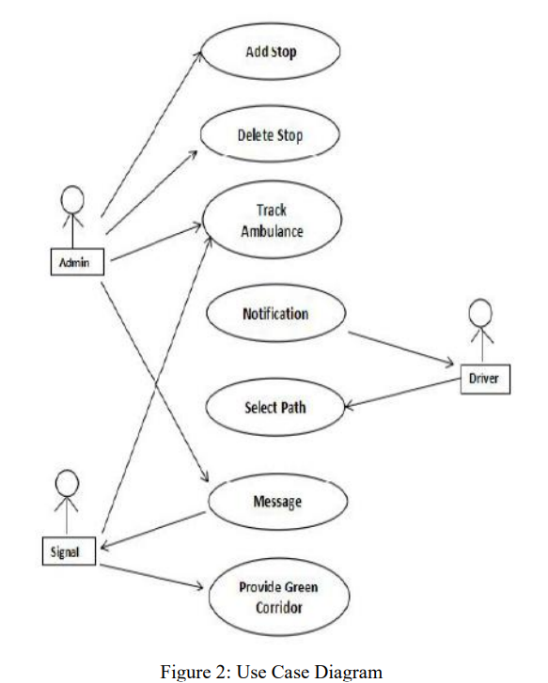

Use case diagram with three actors—admin, signal, and driver—is shown in the above image. There are seven instances that illustrate various operations. The administrator will follow the ambulance and add or remove stops. The traffic control department will also receive a note from the admin. The ambulance will be tracked by the other actor signal (traffic control department), which will then get a message and then open a green corridor. The driver, the last actor, will be notified and will choose a path that will give the source and destination's root.

**AI – Deduction System Methodology**

This uses cameras that are already installed at the signals as an input to the system to identify the ambulance by its picture. This analyses the picture that is being updated in real-time using AI that has been taught to recognise the ambulance using a pretrained collection of photographs and compares them with the real-time data model to see whether it is a legitimate ambulance. The system is also connected to a real ambulance, which when it approaches sounds its siren and is recognised as an emergency

We set up a group of three to four Camera for an ambulance. According to the scenario, each Camera can operate in a variety of states (cam 1, cam 2, h, g, etc.). Cam 1 – It signals or warns the approaching vehicle to make room or clear the path. Cam  2- It determines if the space between Cam 1 and the ambulance, as depicted, has been cleared. Otherwise, it instructs or signals the car to yield, and if necessary, it takes pictures of the Ambulance vehicle plate. H- When there are no signal points, it stops the cars using the red signal. It will either wait for another drone to take its position or serve as a backup.

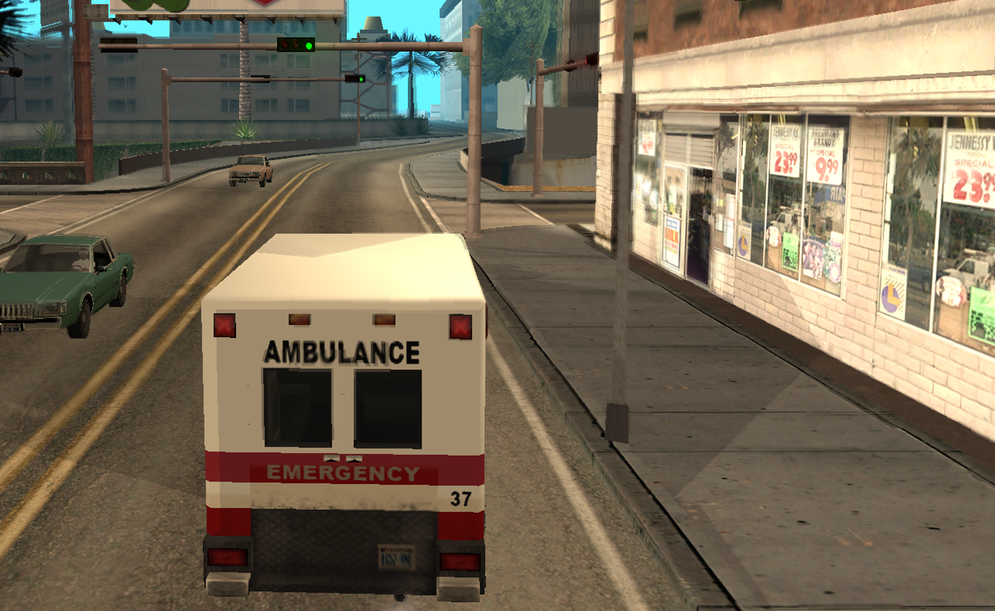

When a voltage is applied to a piezo, which is used to detect and play tones, it vibrates and produces a tone. GPS is used for navigation and tracking. Without the use of manual methods, the vehicle is tracked. The injured accident victims can receive emergency medical care quickly via this technology, potentially saving their lives. These drones can be used effectively by utilising artificial intelligence Technique to detect the exact location of accident spot and provide the medical services because people living in urban areas, in particular, are unable to receive immediate medical help due to heavy traffic, even if the patients are travelling in their own vehicle. This is helpful in cases of accidents as well as life-threatening illnesses including heart attacks, strokes, and other emergencies requiring prompt medical attention. In the Golden Hours, people can be saved without being significantly harmed by the attacks.

**Technology for Communication**

The gateway and the sensors have been connected through LoRa. LoRa (Long Range) digital wireless data transmission technology. It is a brand-new wireless standard created especially for robust, low-power communications. Long Range, or LoRa, is primarily aimed for M2M and IoT networks. With the help of this technology, several apps running on the same network will be able to communicate through public or multi-tenant networks. Smart IoT applications made possible by LoRa technology address some of the most pressing issues confronting our world, including energy management, resource conservation, pollution control, infrastructure efficiency, disaster avoidance, and more. The IoT's DNA, LoRa Technology, is what makes the world a smarter place. Long range, low power use, and secure data transfer are some of its attractive qualities for IoT applications. The technology has a wider range than cellular networks and may be used by public, private, or hybrid networks. The number of nodes that one LoRa gateway can manage is up to millions. Since the signals may travel over long distances with little infrastructure needed, building a network is both cheaper and quicker to deploy. In order to extend the battery life of the nodes and increase network capacity, LoRa also includes an adjustable data rate algorithm. For secure communications, the LoRa protocol has several layers, including encryption at the network, application, and device levels.